Assignment 5

Zac Crane

14151501

CS4320

01 March 2015

**Inventory Management System**

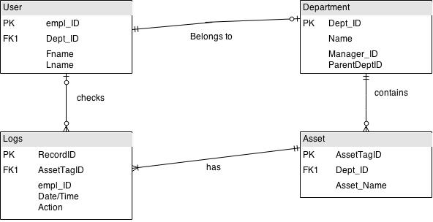

This is a basic Crows Foot ERD that covers the inventory management system. I was able to utilize an ERD from class to create this diagram. A user is able to check logs (if necessary, hence the 0 to one for users and the 0 to many for the logs). Zero or one users can check zero or many logs. A user belongs to zero (sys admin?) or one department. The department contains zero or many assets. The asset has one or more logs about its history (should probably be a zero to many since there won’t necessarily be a log for that asset).

**Learning Management System**

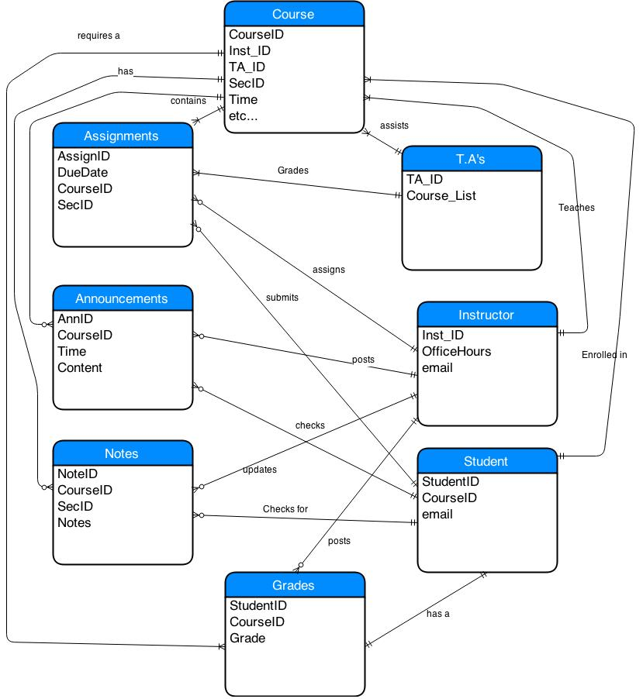

The LMS ERD is a lot more complex than the IMS one. In this ERD, a course has many various components that make it up, such as assignments, announcements, notes and grades. The course entity also has instructors and TA’s and a student will be enrolled in it. The TA in this ERD plays a minimalistic role of only assisting with a course and grading assignments. The instructor is left to assign/ issue assignments, announcements, and notes. The instructor also updates the grades. The student is able to check all of the courses sub entities.

**CS Submit**

Class Diagram

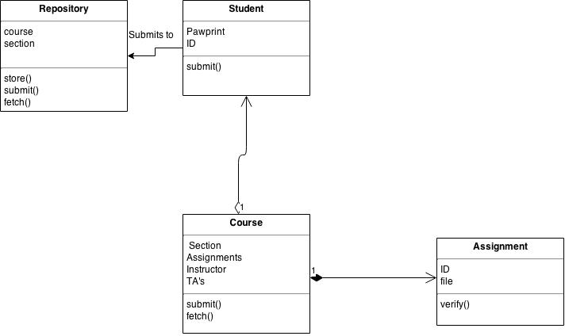

This class diagram was very difficult for me to create. I did not know exactly what needed to be shown by it or what scale to create it to so I created one to the best of my ability. The repository is the overall class represented here. A student class submits to the Repository. The student is an association of course. The course class is aggregated by the assignment class since it is needed to complete the overall structure of the course. A student uses the Course class to submit an assignment to the repository.

Sequence Diagram

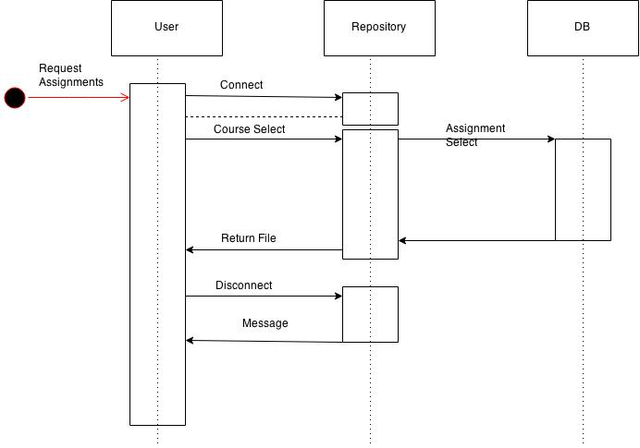

The sequence diagram for requesting assignments is displayed above. The user first connects to the repository. After a connection is made, the course is selected and relayed to the repository. Once the course is selected, the assignment is picked out from the DB and the requested file is returned to the user. After getting the file, the user would then disconnect and receive a confirmation of a successful disconnect.